DAVID DOWELL | ORLANDO REALTOR & REAL ESTATE ATTORNEY
THE COMPLETE
ORLANDO HOME
BUYER'S GUIDE
2026 EDITION
How to Plan, Finance, Search, Negotiate & Close
on a Home in Central Florida
DAVID DOWELL
Orlando Realtor & Real Estate Attorney
Serving Orlando and Southwest Orlando communities
Windermere • Winter Garden • Horizon West • Clermont • Dr. Phillips

Educational guide - not individualized legal, tax, lending, insurance, or financial advice


ORLANDO HOME BUYER'S GUIDE 2026
DAVID DOWELL | ORLANDO REALTOR & REAL ESTATE ATTORNEY

START HERE
Welcome: Buy With a Plan, Not Just a Search
Central Florida buyer guidance from contract to closing

Buying a home is not one decision. It is a sequence of decisions involving financing, neighborhoods, property condition, insurance, contracts, inspections, title, timing, negotiation and closing. In Central Florida, those decisions can vary substantially from one community - and sometimes one subdivision - to the next.

This guide is designed to help you understand the process before you are under pressure. My goal is to help buyers know what questions to ask, what risks to evaluate, and how the pieces fit together from the first planning conversation through the day you receive the keys.

THE REALTOR + ATTORNEY ADVANTAGE

A real estate transaction is both a market transaction and a contract transaction. My background as a Realtor and real estate attorney allows me to approach the purchase with both perspectives in mind: value, negotiation, property selection and market conditions on one side; contract language, deadlines, title and legal risk on the other.

Nothing in this guide creates an attorney-client relationship or replaces advice tailored to a particular transaction.

ORLANDO HOME BUYER'S GUIDE 2026

DAVID DOWELL | ORLANDO REALTOR & REAL ESTATE ATTORNEY

CONTENTS
Guide at a Glance
Central Florida buyer guidance from contract to closing

1. Define Your Buying Strategy
2. The Orlando Market Is Many Markets
3. Budget Beyond the Purchase Price
4. Financing & Pre-Approval
5. Cash Buyers
6. Choosing the Right Area
7. Windermere
8. Winter Garden
9. Horizon West
10. Clermont
11. Dr. Phillips
12. New Construction
13. Resale Homes
14. Condos & Townhomes
15. HOAs & Community Rules
16. Insurance in Florida
17. Property Taxes & Homestead
18. Flood Zones & Other Property Risks
19. Building Your Home Search
20. Touring Homes Like a Buyer
21. Comparing Properties
22. Understanding Market Value
23. Making an Offer
24. Price vs. Terms
25. Florida Contracts
26. Deposits & Escrow
27. Inspection Periods
28. The Home Inspection
29. Negotiating Repairs
30. Financing Contingencies
31. Appraisal
32. Low Appraisal
33. Seller Disclosures
34. Title & Survey
35. Liens, Permits & Municipal Issues
36. Closing Costs
37. Your Loan Estimate & Cash to Close
38. Final Walk-Through
39. Closing Day
40. After Closing
41. Buying Before Selling
42. Relocating to Orlando
43. Out-of-State Buyers
44. Vacation & Second Homes
45. Investment Property Basics
46. Foreign Buyers
47. Common Buyer Mistakes
48. 60-Day Buyer Plan
49. Buyer Checklist
50. Questions to Ask Your Realtor
51. Questions to Ask a Lender
52. Attorney's Contract Checklist
53. Glossary
54. Next Steps

ORLANDO HOME BUYER'S GUIDE 2026
DAVID DOWELL | ORLANDO REALTOR & REAL ESTATE ATTORNEY

PLANNING
1. Define Your Buying Strategy
Central Florida buyer guidance from contract to closing

Before opening listing apps, define the outcome you want. A buyer who needs a primary residence near work has a different strategy from a relocating family, a second-home buyer, or an investor. Your strategy should identify the property type, geographic range, timing, financing, must-haves, acceptable compromises and maximum comfortable monthly housing cost.
Primary residence, second home, vacation property or investment?
Target move date and any lease or sale deadlines
Preferred communities and realistic commute radius
Minimum bedrooms, baths, garage and lot requirements
New construction versus resale
Monthly payment ceiling - not merely a lender's maximum approval

BUYER TIP
Separate your list into Must Have, Strong Preference and Nice to Have. This makes fast decisions easier when a strong property appears. As you pursue your home search, these categories will make a lot of sense and help you sift through your choices.

ORLANDO HOME BUYER'S GUIDE 2026
DAVID DOWELL | ORLANDO REALTOR & REAL ESTATE ATTORNEY

LOCAL STRATEGY
2. The Orlando Market Is Many Markets
Central Florida buyer guidance from contract to closing

There is no single 'Orlando market.' Pricing, inventory, HOA structure, home age, school zoning, commute patterns, insurance considerations and buyer competition can differ materially among Windermere, Winter Garden, Horizon West, Clermont, Dr. Phillips, Lake Nona, Winter Park, Celebration and other communities.
A metro-wide statistic can provide context, but the most useful comparison for a purchase is usually the immediate competitive set: similar homes, similar condition, similar neighborhood, similar lot and similar buyer pool.

MARKET PERSPECTIVE
Do not use a headline about Orlando prices as a substitute for evaluating the specific house you are considering. The neighborhoods and suburbs differ greatly - more so than most big cities.

ORLANDO HOME BUYER'S GUIDE 2026
DAVID DOWELL | ORLANDO REALTOR & REAL ESTATE ATTORNEY

MONEY
3. Budget Beyond the Purchase Price
Central Florida buyer guidance from contract to closing

The purchase price is only one component of affordability. A better budget estimates principal and interest, property taxes, homeowners insurance, flood insurance if applicable, HOA or condominium charges, mortgage insurance where applicable, utilities, maintenance and reserves for future repairs.

Costt | What to budget for for
Down payment | Depends on loan program and strategy
Closing costs | Lender, title, recording, prepaid and other transaction charges
Insurance | Property-specific; obtain quotes early
Taxes | Review current bill but estimate post-purchase treatment
HOA/Condo | Regular dues plus possible assessments
Maintenance | Roof, HVAC, appliances, landscaping, pool and normal wear

ORLANDO HOME BUYER'S GUIDE 2026
DAVID DOWELL | ORLANDO REALTOR & REAL ESTATE ATTORNEY

FINANCING
4. Financing & Pre-Approval
Central Florida buyer guidance from contract to closing

A strong pre-approval helps you understand your price range and shows sellers that you have taken meaningful financing steps. Ask the lender what documentation has been reviewed, whether the file has been underwritten, what assumptions were used for taxes and insurance, and what could change the approval.
Compare rate and APR, but also lender fees and points.
Ask whether quoted payments include realistic taxes, insurance and HOA costs.
Avoid new debt, large unexplained transfers and major credit changes before closing.
Confirm how long the rate lock lasts and what happens if closing is delayed.

ATTORNEY’S PERSPECTIVE
The financing language in the purchase contract matters. A pre-approval letter is not the same thing as a contractual right to cancel if financing later fails. And a lender’s Pre-Qualification is not the same as a Pre-Approval. Ask your Realtor or Attorney what the difference is.



ORLANDO HOME BUYER'S GUIDE 2026
DAVID DOWELL | ORLANDO REALTOR & REAL ESTATE ATTORNEY

FINANCING
5. Cash Buyers
Central Florida buyer guidance from contract to closing

Cash can simplify financing risk, but cash buyers still need a disciplined process. Proof of funds, inspection rights, title review, survey issues, insurance availability, HOA documents and closing logistics remain important. Decide in advance whether you want an appraisal or other valuation even when a lender does not require one.

If a buyer wants to make an offer and is paying all cash, this is a strong incentive for the seller to consider this offer. Not only is there no chance of financing falling through, but the buyer also does not have to wait 30 to 45 days to close due to lender doc preparation. Most cash buyers can close within 10 days.

Thus, cash offers can sometimes ‘win’ a bidding war by offering a bit lower purchase price.

ORLANDO HOME BUYER'S GUIDE 2026
DAVID DOWELL | ORLANDO REALTOR & REAL ESTATE ATTORNEY

NEIGHBORHOODS
6. Choosing the Right Area
Central Florida buyer guidance from contract to closing

Start with lifestyle and logistics rather than a list of subdivisions. Consider commute destinations, airport access, medical care, shopping, recreation, lot size, neighborhood amenities, new-construction activity, HOA restrictions and how often you expect to use attractions or downtown Orlando.

IMPORTANT
School boundaries and ratings can change. Verify current zoning and programs directly with the applicable school district rather than relying solely on a listing.

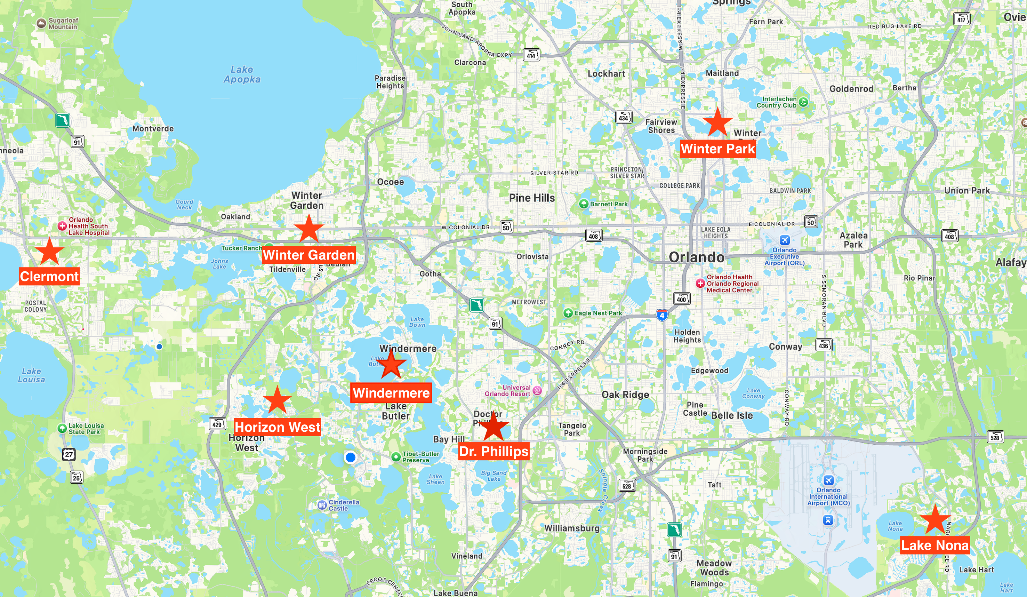

ORLANDO HOME BUYER'S GUIDE 2026
DAVID DOWELL | ORLANDO REALTOR & REAL ESTATE ATTORNEY

NEIGHBORHOOD SPOTLIGHT
7. Windermere
Central Florida buyer guidance from contract to closing

Windermere is often considered by buyers seeking an established southwest Orlando location, lakes, luxury options and proximity to employment, attractions and surrounding communities. Housing ranges from older homes and lakefront estates to gated subdivisions. Evaluate the exact location carefully because a Windermere mailing address does not necessarily mean the property is within the Town of Windermere.

WHAT TO COMPARE
Recent nearby comparable sales
HOA or condominium restrictions and fees
Age of roof, HVAC and major systems
Traffic and commute at the times you will actually travel
Future development and nearby land uses


ORLANDO HOME BUYER'S GUIDE 2026
DAVID DOWELL | ORLANDO REALTOR & REAL ESTATE ATTORNEY

NEIGHBORHOOD SPOTLIGHT
8. Winter Garden
Central Florida buyer guidance from contract to closing

Winter Garden combines an established historic downtown with substantial newer residential development. Buyers often compare access to Plant Street, newer communities, lot sizes, amenities, commuting routes and proximity to Horizon West. Resale and new-construction options can behave differently.

WHAT TO COMPARE
Recent nearby comparable sales
HOA or condominium restrictions and fees
Age of roof, HVAC and major systems
Traffic and commute at the times you will actually travel
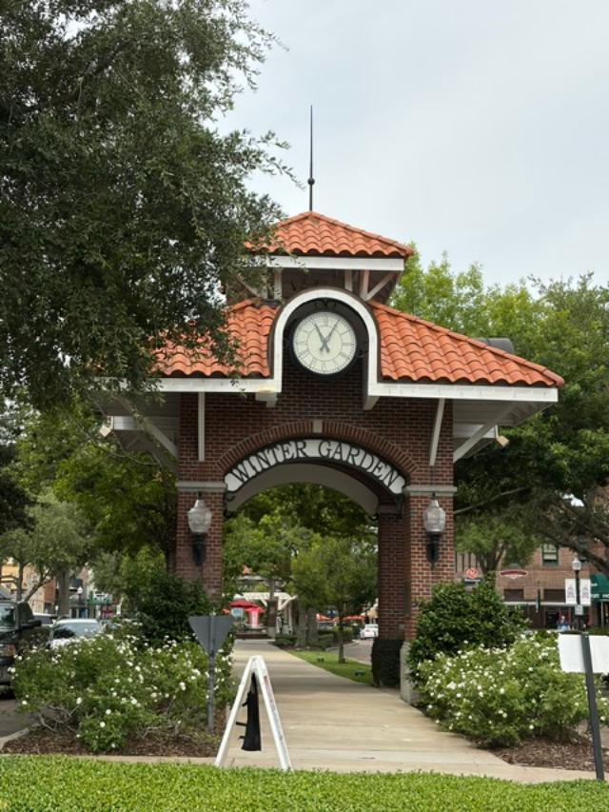
Future development and nearby land uses

ORLANDO HOME BUYER'S GUIDE 2026
DAVID DOWELL | ORLANDO REALTOR & REAL ESTATE ATTORNEY

NEIGHBORHOOD SPOTLIGHT
9. Horizon West
Central Florida buyer guidance from contract to closing

Horizon West is a large master-planned area in southwest Orange County with many newer communities, town centers, trails and continuing development. Buyers should compare builder quality, CDD or special district considerations where applicable, HOA structure, future construction around the property and commute routes.

WHAT TO COMPARE
Recent nearby comparable sales
HOA or condominium restrictions and fees
Age of roof, HVAC and major systems
Traffic and commute at the times you will actually travel
Future development and nearby land uses


ORLANDO HOME BUYER'S GUIDE 2026
DAVID DOWELL | ORLANDO REALTOR & REAL ESTATE ATTORNEY

NEIGHBORHOOD SPOTLIGHT
10. Clermont
Central Florida buyer guidance from contract to closing

Clermont offers rolling terrain, lakes, established neighborhoods and significant newer development. Buyers may find more space for the money than in some closer-in Orlando communities, but should evaluate commute time, toll-road access, community fees and the exact location within the broader Clermont area.

WHAT TO COMPARE
Recent nearby comparable sales
HOA or condominium restrictions and fees
Age of roof, HVAC and major systems
Traffic and commute at the times you will actually travel
Future development and nearby land uses
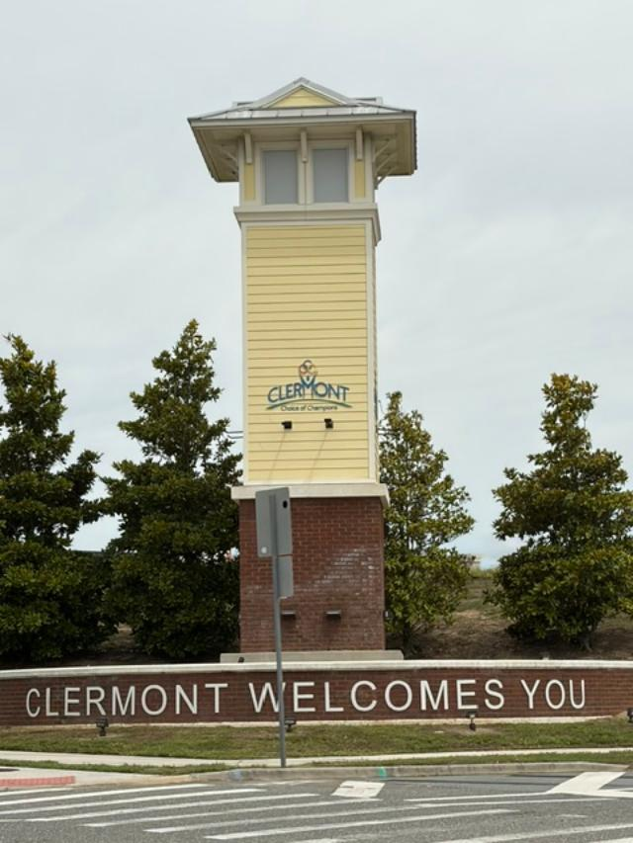

ORLANDO HOME BUYER'S GUIDE 2026
DAVID DOWELL | ORLANDO REALTOR & REAL ESTATE ATTORNEY

NEIGHBORHOOD SPOTLIGHT
11. Dr. Phillips
Central Florida buyer guidance from contract to closing

Dr. Phillips is an established southwest Orlando area known for convenient access to major roads, dining, attractions and employment centers. Inventory can include older single-family neighborhoods, gated communities, luxury properties, condos and townhomes. Condition and renovation level can significantly affect value.

WHAT TO COMPARE
Recent nearby comparable sales
HOA or condominium restrictions and fees
Age of roof, HVAC and major systems
Traffic and commute at the times you will actually travel
Future development and nearby land uses
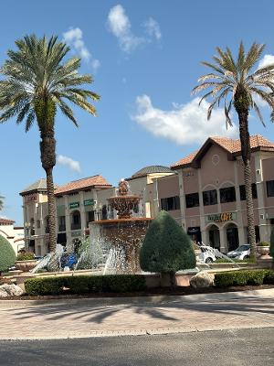

ORLANDO HOME BUYER'S GUIDE 2026
DAVID DOWELL | ORLANDO REALTOR & REAL ESTATE ATTORNEY

PROPERTY TYPE
12. New Construction
Central Florida buyer guidance from contract to closing

New construction can offer modern layouts, energy efficiency, warranties and customization, but the builder's sales representative represents the builder's interests. Compare base price with lot premiums, structural options, design-center upgrades, financing incentives, closing-cost incentives and the cost of completed resale homes nearby.

ATTORNEY’S PERSPECTIVE
Builder contracts are commonly builder-drafted and can differ substantially from standard resale contracts. Pay particular attention to deposit provisions, construction deadlines, change orders, financing, inspections, remedies, arbitration, warranty language and the builder's right to make substitutions.

There are many home builders in the Orlando area. Each has its own reputation in the industry. Don’t always go with the cheapest builder if you are building a custom home. And don’t always assume a builder in a specific subdivision is the creator of the perfect home.

Always ask about a builder before buying a new construction home!

ORLANDO HOME BUYER'S GUIDE 2026
DAVID DOWELL | ORLANDO REALTOR & REAL ESTATE ATTORNEY

PROPERTY TYPE
13. Resale Homes
Central Florida buyer guidance from contract to closing

A resale home lets you evaluate an existing neighborhood and an existing structure, but condition varies widely. The age and remaining life of the roof, HVAC, water heater, electrical components, plumbing, windows, pool equipment and appliances can affect both your immediate costs and insurability.

Price alone is not the only factor in purchasing a home. You want to make sure the house is in good working order and is not going to be a money pit. Of course, most resale homes in good condition will still need a little love from the new owner. But make sure your inspection is thorough enough to inform you of what to expect.


ORLANDO HOME BUYER'S GUIDE 2026

DAVID DOWELL | ORLANDO REALTOR & REAL ESTATE ATTORNEY

PROPERTY TYPE
14. Condos & Townhomes
Central Florida buyer guidance from contract to closing

Condominium and townhome purchases require attention to the association as well as the unit. Review budgets, reserves, insurance, pending assessments, litigation, maintenance responsibilities, rental restrictions, approval procedures and the governing documents. Financing and insurance requirements may also differ from detached homes.



ORLANDO HOME BUYER'S GUIDE 2026
DAVID DOWELL | ORLANDO REALTOR & REAL ESTATE ATTORNEY

DUE DILIGENCE
15. HOAs & Community Rules
Central Florida buyer guidance from contract to closing

HOAs can provide amenities and community standards, but they also impose contractual restrictions. Before your contractual deadlines expire, understand dues, special assessments, architectural rules, parking, leasing, pets, vehicles, fences, exterior changes and any use that matters to you.

Some of the biggest horror stories in real estate are those involving HOA rules. Make sure you read through all condo/townhome docs, including financials, before purchasing. These docs will reveal what you can and cannot do, as well as show you if the community is financially sound so that future monthly dues due not get assessed.

DO NOT ASSUME
A listing description is not a substitute for the governing documents. If a pool, rental plan, work vehicle, fence, boat, home business or exterior modification matters to you, verify the rule.
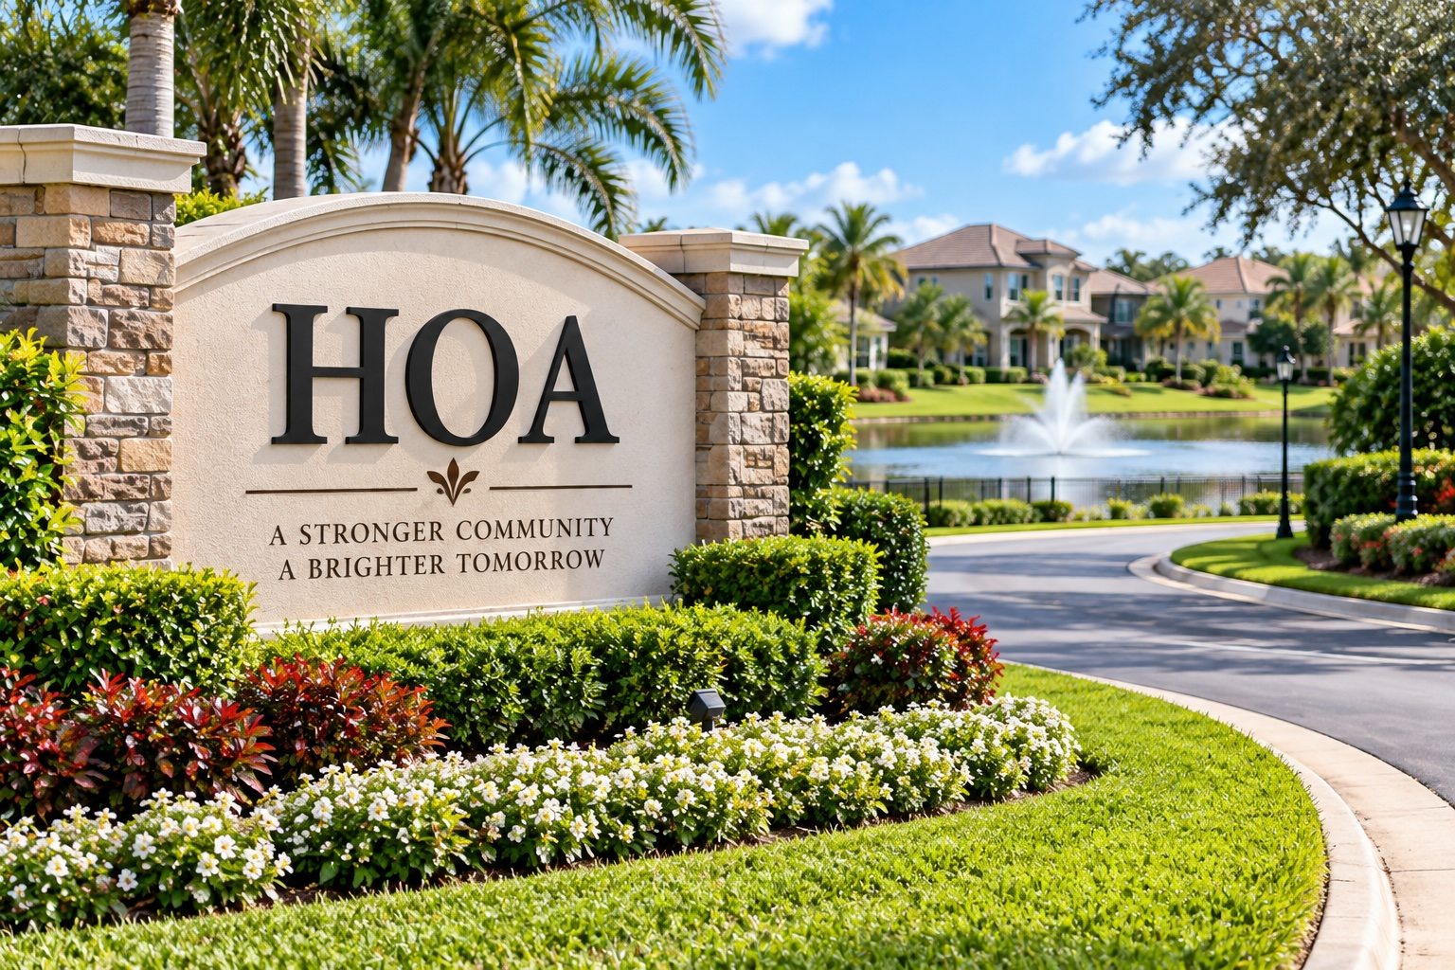

ORLANDO HOME BUYER'S GUIDE 2026
DAVID DOWELL | ORLANDO REALTOR & REAL ESTATE ATTORNEY

RISK & COST
16. Insurance in Florida
Central Florida buyer guidance from contract to closing

Insurance should be investigated early, not days before closing. Premiums and eligibility can be affected by roof age and condition, wind mitigation features, electrical systems, plumbing, prior claims, flood exposure and insurer underwriting rules. Obtain property-specific quotes during your due-diligence period whenever possible.

Homeowners coverage
Wind/hurricane considerations
Flood coverage where appropriate
Condo unit-owner coverage
Liability and umbrella coverage discussions with your insurance professional

ORLANDO HOME BUYER'S GUIDE 2026
DAVID DOWELL | ORLANDO REALTOR & REAL ESTATE ATTORNEY

ONGOING COSTS
17. Property Taxes & Homestead
Central Florida buyer guidance from contract to closing

Do not assume the seller's current property-tax bill will be your future bill. Florida property taxes are affected by assessed value, exemptions and other factors. A change in ownership can change the taxable picture. Use county and state resources or a qualified professional to estimate future taxes, and investigate homestead exemption eligibility after purchasing a qualifying primary residence.

And once you do purchase a new home, make sure you contact the county property appraiser’s office to find out all applicable deadlines for applying for the exemptions.

ORLANDO HOME BUYER'S GUIDE 2026

DAVID DOWELL | ORLANDO REALTOR & REAL ESTATE ATTORNEY

DUE DILIGENCE
18. Flood Zones & Other Property Risks
Central Florida buyer guidance from contract to closing

Flood-zone designation is one part of property risk. Buyers should also consider drainage, prior water intrusion, wetlands, nearby retention areas, sinkhole history or geological concerns where relevant, trees, septic or well systems, and the property's elevation and grading. Insurance requirements and actual physical risk are related but not identical.

A good starting point would be to contact your lender or realtor about a certain property before you make your offer. If the property sits in a flood zone you can contact an insurance company to find out how much the flood premium will be. If sitting in a U.S. designated flood zone, your lender will require flood insurance.

ORLANDO HOME BUYER'S GUIDE 2026

DAVID DOWELL | ORLANDO REALTOR & REAL ESTATE ATTORNEY

SEARCH
19. Building Your Home Search
Central Florida buyer guidance from contract to closing

A productive search is narrow enough to identify meaningful opportunities but broad enough to avoid missing a better fit. Set alerts using realistic criteria, then have your Realtor monitor new listings, price changes, back-on-market properties and competing inventory.

SEARCH STRATEGY
If you would buy a house at $700,000 after negotiation, do not automatically cap the search at $700,000. Depending on market conditions, slightly higher-priced listings may become realistic candidates.

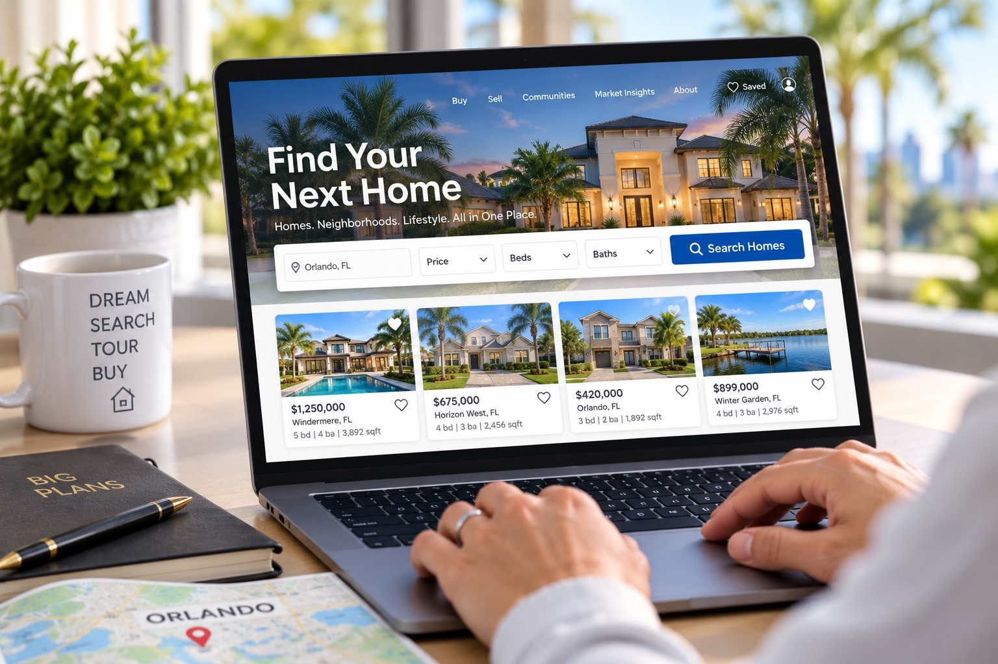

ORLANDO HOME BUYER'S GUIDE 2026

DAVID DOWELL | ORLANDO REALTOR & REAL ESTATE ATTORNEY

SEARCH
20. Touring Homes Like a Buyer
Central Florida buyer guidance from contract to closing

During a showing, look beyond furniture and paint. Observe street traffic, neighboring properties, odors, water staining, cracks, window condition, roof appearance, HVAC age, electrical panels, plumbing fixtures, drainage, pool condition, garage space and signs of deferred maintenance. A showing is not an inspection, but it helps you decide which properties deserve deeper investigation.



ORLANDO HOME BUYER'S GUIDE 2026
DAVID DOWELL | ORLANDO REALTOR & REAL ESTATE ATTORNEY

VALUATION
21. Comparing Properties
Central Florida buyer guidance from contract to closing

Factor | Property A | Property B | Property C
Price
Monthly estimate
Sq. ft./layout
Condition
Roof/HVAC
HOA/fees
Commute
Major concerns

Use the table as a decision tool. The lowest price can become the most expensive choice after insurance, repairs, association costs or renovation.

ORLANDO HOME BUYER'S GUIDE 2026
DAVID DOWELL | ORLANDO REALTOR & REAL ESTATE ATTORNEY

VALUATION
22. Understanding Market Value
Central Florida buyer guidance from contract to closing

Market value is not determined by what the seller paid, what the seller needs, or an automated estimate alone. A buyer-side comparative market analysis examines recent sales, active competition, pending activity when available, property condition, location, size, lot, upgrades and market momentum.

NEGOTIATION PRINCIPAL
The goal is not to 'win' by getting a discount. The goal is to acquire the right property on terms that make sense relative to its value and your alternatives.


ORLANDO HOME BUYER'S GUIDE 2026
DAVID DOWELL | ORLANDO REALTOR & REAL ESTATE ATTORNEY

OFFER
23. Making an Offer
Central Florida buyer guidance from contract to closing

An offer is a package of economic and legal terms. Purchase price matters, but so do deposit, financing, inspection period, closing date, occupancy, personal property, concessions, appraisal strategy and other contingencies. In a competitive situation, improving terms can sometimes be more effective than simply raising price.

Make sure you discuss contract terms thoroughly with your Realtor or Attorney before signing the purchase contract. Many terms will be valued by the seller and may decrease the amount of your purchase price.

One of the main sources of criticism I have heard about realtors is that many don’t thoroughly explain all the terms and con editions in the contract. Having an attorney on your side can make a huge difference in not only getting your offer accepted, but get accepted at the lowest purchase price possible.

ORLANDO HOME BUYER'S GUIDE 2026
DAVID DOWELL | ORLANDO REALTOR & REAL ESTATE ATTORNEY

OFFER
24. Price vs. Terms
Central Florida buyer guidance from contract to closing

Term | Why a seller may care
Price | Net proceeds and appraisal risk
Deposit | Perceived commitment and contractual security
Financing | Probability and timing of closing
Inspection | Length and scope of uncertainty
Closing date | Seller's move and next purchase
Concessions | Effect on seller's net
Occupancy | Whether seller needs time after closing

ORLANDO HOME BUYER'S GUIDE 2026
DAVID DOWELL | ORLANDO REALTOR & REAL ESTATE ATTORNEY

LEGAL
25. Florida Contracts
Central Florida buyer guidance from contract to closing

Florida residential purchases are commonly documented on standardized forms, but standardized does not mean simple. Contract versions, riders and addenda can allocate risk differently. Read the actual contract you are signing, not a summary of what someone says it does.

ATTORNEY’S PERSPECTIVE
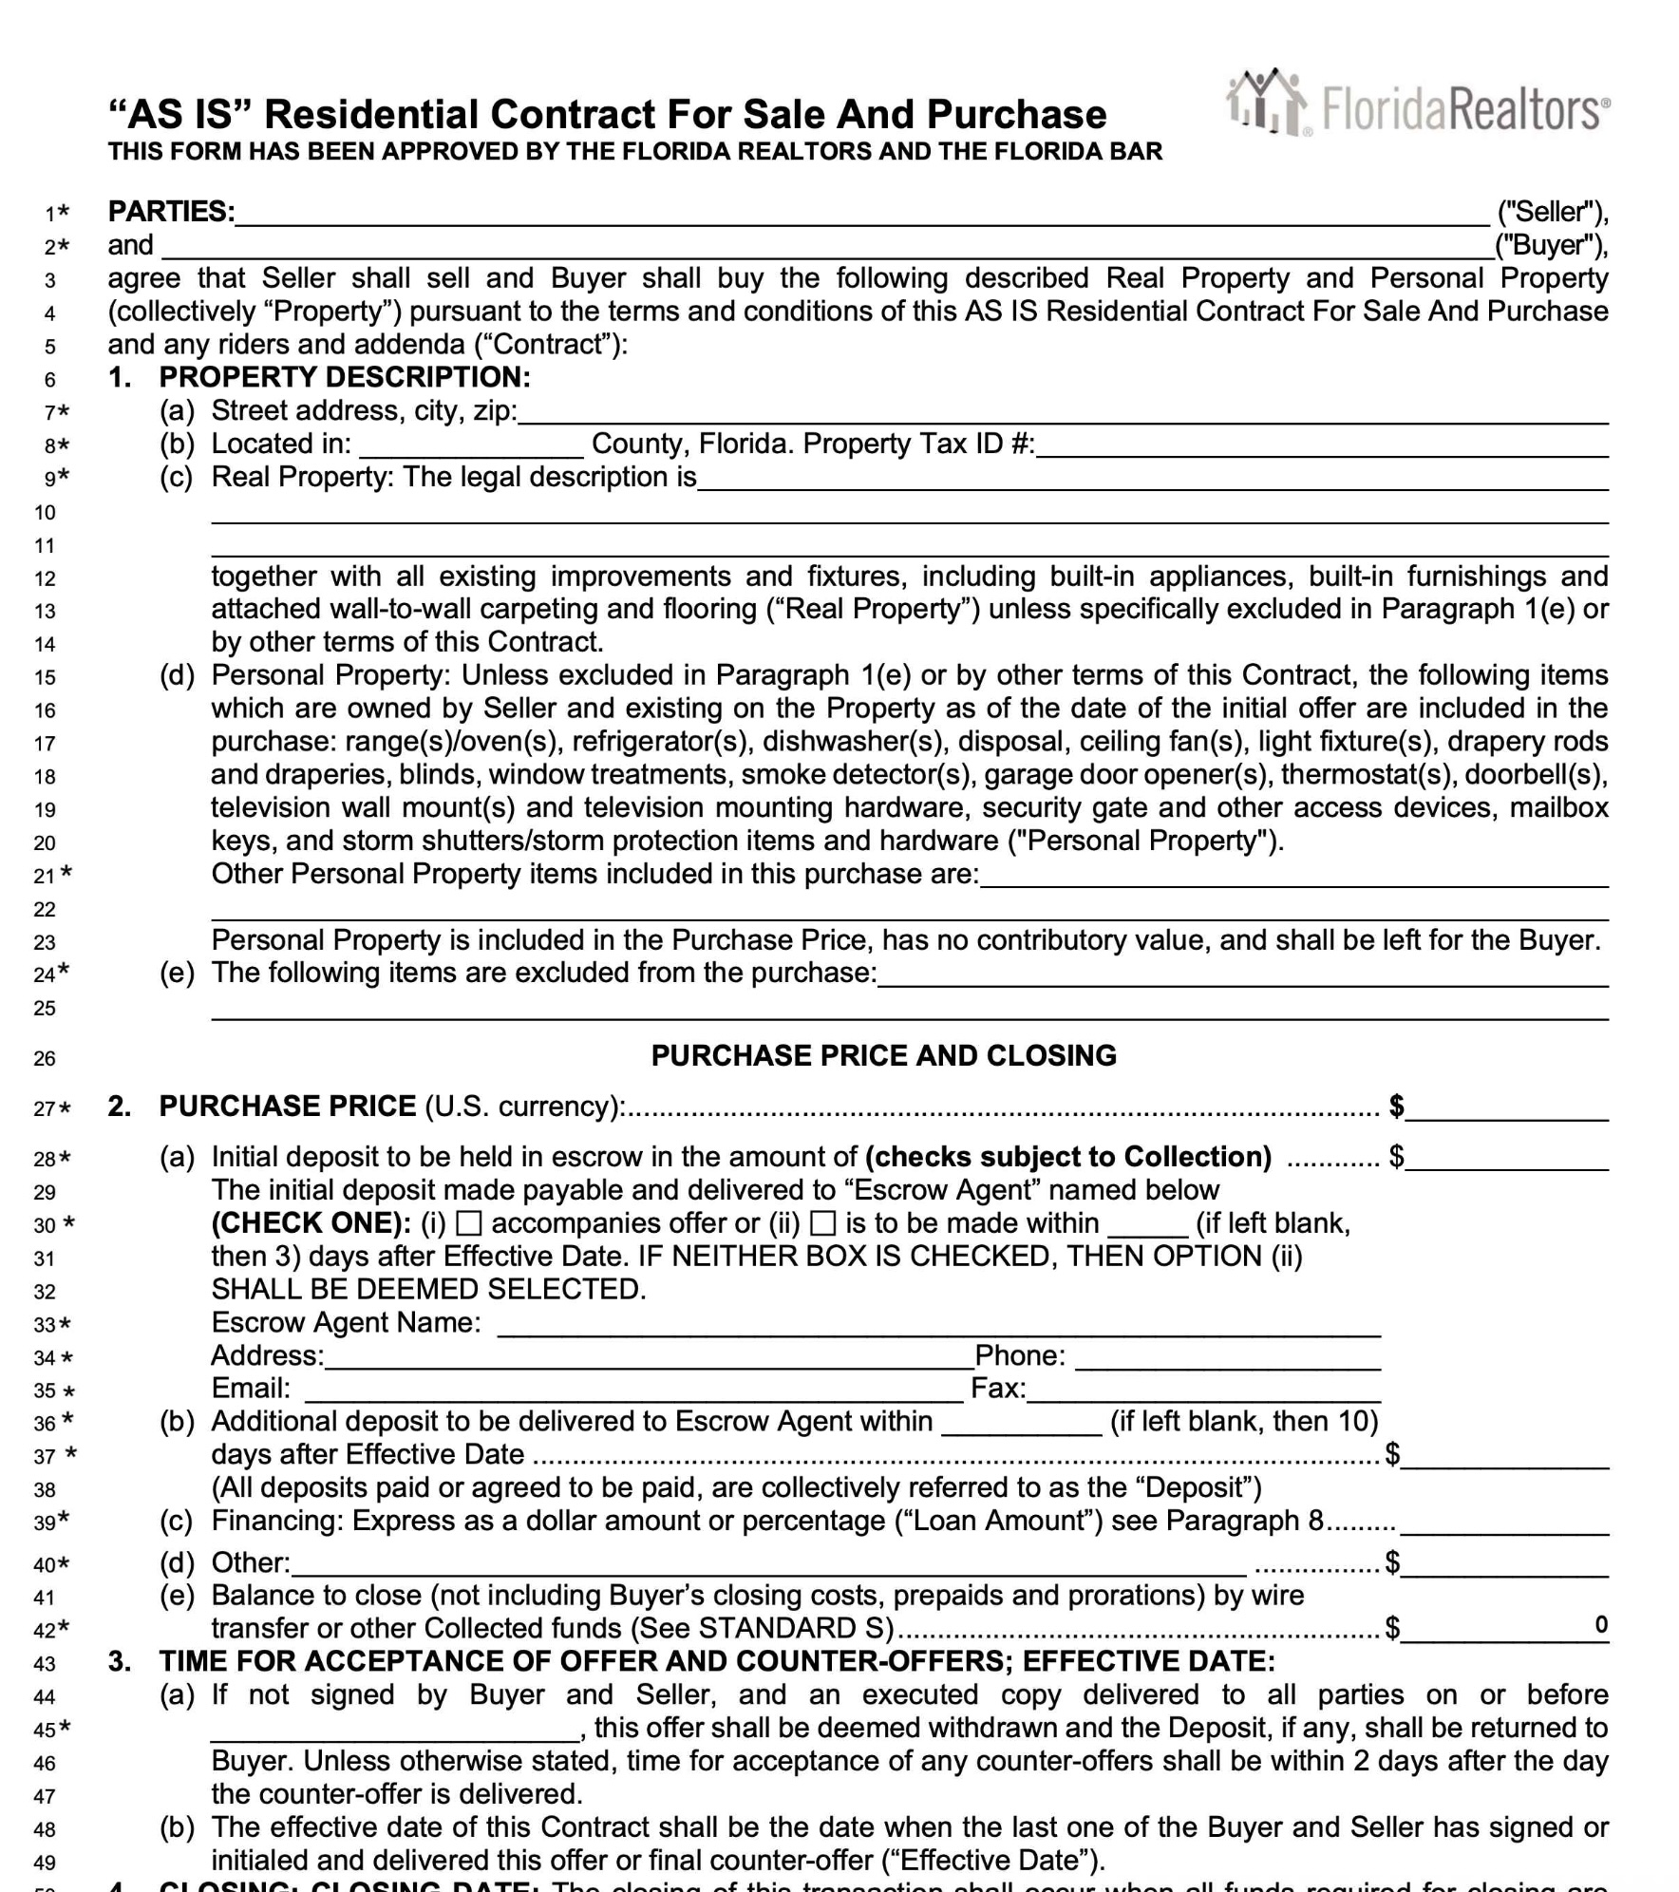
Deadlines are especially important. Financing, inspection, title, association, appraisal and closing provisions can create rights that expire if not exercised correctly and on time. Your particular contract controls.

ORLANDO HOME BUYER'S GUIDE 2026
DAVID DOWELL | ORLANDO REALTOR & REAL ESTATE ATTORNEY

LEGAL
26. Deposits & Escrow
Central Florida buyer guidance from contract to closing

The earnest-money deposit is governed by the contract. Understand the amount, due date, escrow agent and circumstances in which it may be refundable or at risk. Never assume a deposit is automatically refundable simply because the transaction does not close.

The amount of the deposit can be any amount you want it to be. You want it low enough that it’s easy to come up with but high enough that the seller knows you are serious. If the seller accepts the offer then seller will be taking the property off the market for 30 to 45 days with the expectation that you will close. Therefore, seller needs to know you are serious. Your Realtor can advise on the amount of the deposit.

ORLANDO HOME BUYER'S GUIDE 2026

DAVID DOWELL | ORLANDO REALTOR & REAL ESTATE ATTORNEY

DUE DILIGENCE
27. Inspection Periods
Central Florida buyer guidance from contract to closing

The inspection period is your opportunity to investigate the property within the rights created by your contract. Different contract forms can provide different cancellation or repair rights. Schedule inspections promptly so there is time to obtain specialist opinions, estimates and insurance information before the deadline.

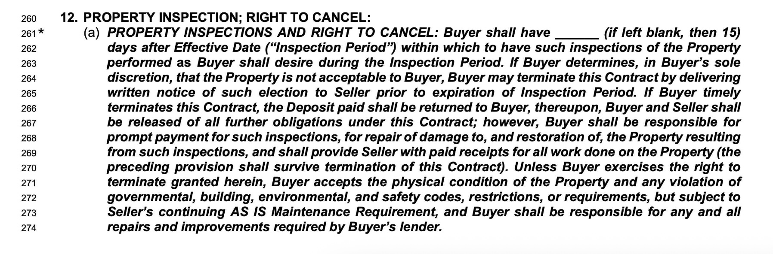

ORLANDO HOME BUYER'S GUIDE 2026

DAVID DOWELL | ORLANDO REALTOR & REAL ESTATE ATTORNEY

DUE DILIGENCE
28. The Home Inspection
Central Florida buyer guidance from contract to closing

General home inspection
Wood-destroying organism inspection where appropriate
Roof evaluation
HVAC specialist
Plumbing/sewer scope when appropriate
Pool inspection
Electrical specialist
Septic/well inspection
Mold or moisture evaluation when conditions warrant

No inspection guarantees that a property is defect-free. Use qualified professionals and investigate issues that are material to your decision.

ORLANDO HOME BUYER'S GUIDE 2026

DAVID DOWELL | ORLANDO REALTOR & REAL ESTATE ATTORNEY

NEGOTIATION
29. Negotiating Repairs
Central Florida buyer guidance from contract to closing

After inspections, prioritize material issues over a long cosmetic wish list. Depending on the contract and circumstances, the response might involve repairs, a credit, price adjustment, cancellation rights or acceptance as-is. Credits and concessions may be limited by loan rules, so coordinate with the lender.

Negotiating repairs can be one of the most difficult parts of buying a home. Once your inspector goes through the house, they will provide you with a summary of everything. Inspections are very thorough. Be prepared to see a report that tells you there are many things wrong with your intended new home. This is normal.

All homes have issues. It’s the major ones that you want to look out for. So consider that before you walk away from a deal. If something truly was major and unexpected then, of course, you will want to re-negotiate. But, unfortunately, the little and immaterial things will follow you into your new home.

ORLANDO HOME BUYER'S GUIDE 2026
DAVID DOWELL | ORLANDO REALTOR & REAL ESTATE ATTORNEY

LEGAL
30. Financing Contingencies
Central Florida buyer guidance from contract to closing

A financing contingency is contractual protection, not a general promise that the buyer can cancel for any loan problem. Pay attention to application deadlines, loan type, loan amount, approval periods, notice requirements and obligations to use diligent effort. Discuss material financing changes with both the lender and the professionals advising you on the contract.

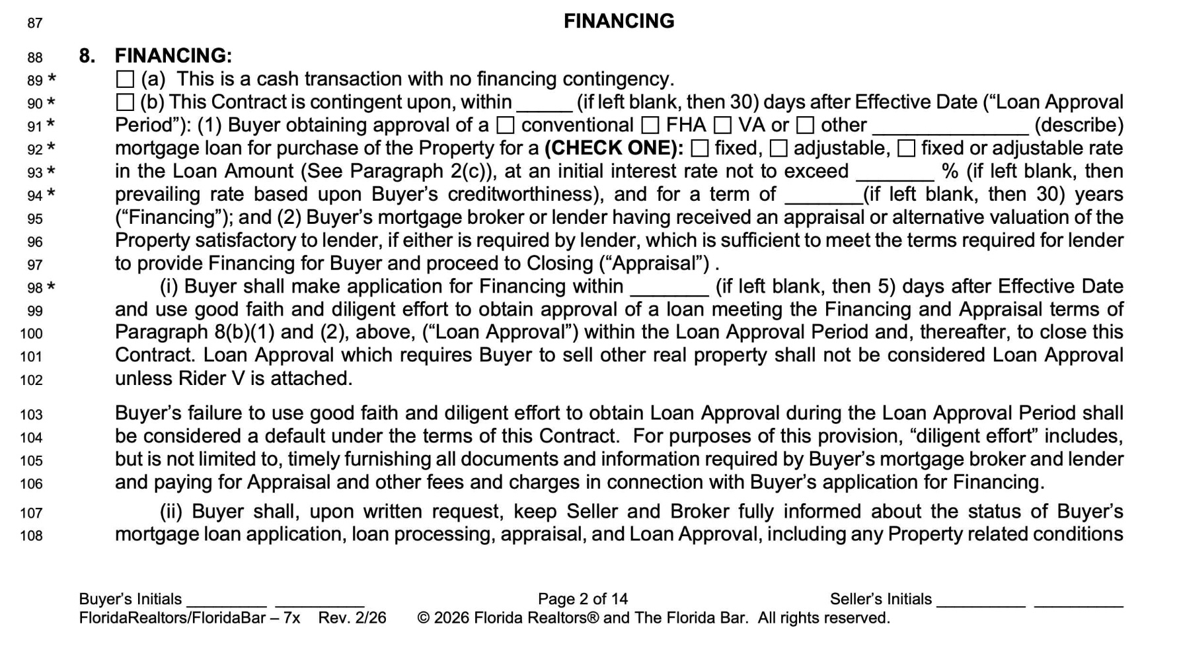

ORLANDO HOME BUYER'S GUIDE 2026

DAVID DOWELL | ORLANDO REALTOR & REAL ESTATE ATTORNEY

FINANCING
31. Appraisal
Central Florida buyer guidance from contract to closing

An appraisal is primarily a lender's valuation tool. It does not replace a home inspection and does not guarantee resale value. If the property appraises at or above the required level, the financing process generally continues; if it appraises low, your options depend on the contract and negotiations. This is why it is very important to have an attorney’s eyes on your contract before signing.

Typically, if you are financing a loan for the purchase of the house, your lender will use their chosen appraiser to go look at the property before closing. If you want a copy of that report, let your lender know. After all, you will be charged at closing for that appraisal.

ORLANDO HOME BUYER'S GUIDE 2026
DAVID DOWELL | ORLANDO REALTOR & REAL ESTATE ATTORNEY

NEGOTIATION
32. Low Appraisal
Central Florida buyer guidance from contract to closing

Sometimes, the appraisal will come back showing a valuation below the agreed upon purchase price. If that happens, you have several choices, based on the language you put in the contract.

Review the appraisal for factual errors and comparable-sale issues.
Determine your contractual rights and deadlines.
Evaluate whether the price still makes sense to you.
Consider a price reduction, buyer contribution to a gap, other restructuring, or cancellation if permitted.
Coordinate any change with the lender before signing an amendment.

ORLANDO HOME BUYER'S GUIDE 2026
DAVID DOWELL | ORLANDO REALTOR & REAL ESTATE ATTORNEY

DUE DILIGENCE
33. Seller Disclosures
Central Florida buyer guidance from contract to closing

Seller disclosures can provide valuable information, but they are not a warranty and should not replace independent investigation. Compare disclosure information with inspection findings, permits, insurance information and your own observations. Ask follow-up questions when answers are incomplete or inconsistent.

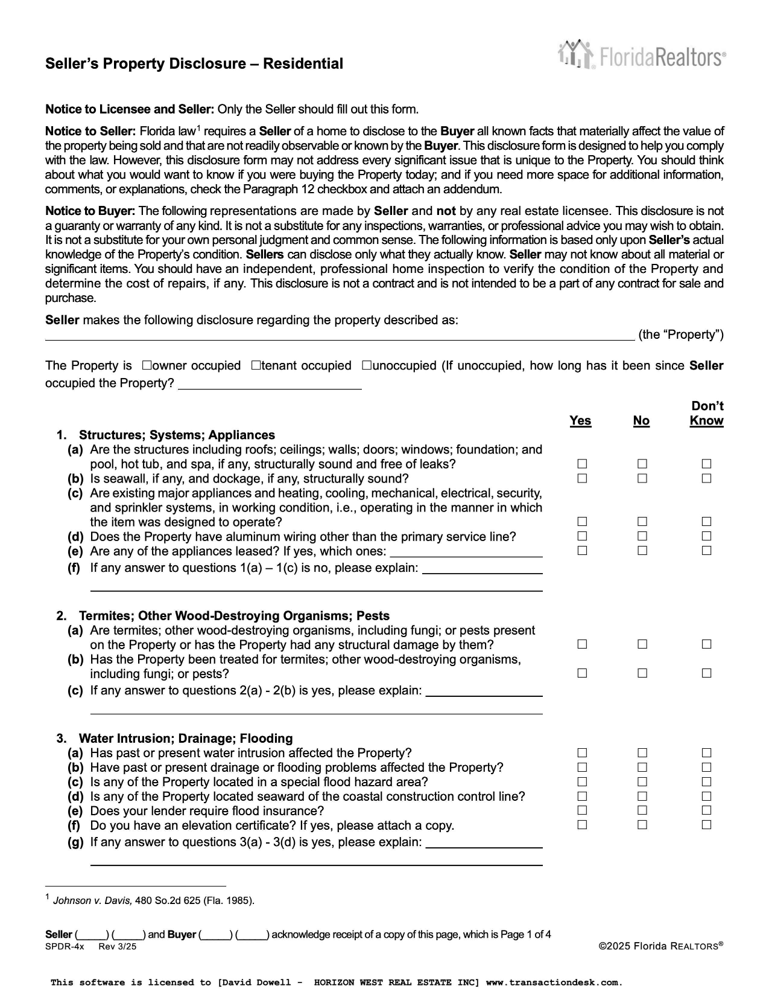
Given the importance of the Seller Disclosure, it is recommended that buyer request said disclosure at or before the time of signing the final purchase contract.

ORLANDO HOME BUYER'S GUIDE 2026

DAVID DOWELL | ORLANDO REALTOR & REAL ESTATE ATTORNEY

LEGAL
34. Title & Survey
Central Florida buyer guidance from contract to closing

Title work addresses ownership and matters affecting the property, such as recorded liens, easements, restrictions and other exceptions. A survey can reveal boundaries, encroachments, improvements, easements and other physical matters. Review title and survey issues within the deadlines in your contract.

ATTORNEY’S PERSPECTIVE
A title insurance policy is important, but the exceptions to coverage matter. The goal is to understand what you are receiving and what recorded or survey matters will remain after closing.


ORLANDO HOME BUYER'S GUIDE 2026

DAVID DOWELL | ORLANDO REALTOR & REAL ESTATE ATTORNEY

LEGAL
35. Liens, Permits & Municipal Issues
Central Florida buyer guidance from contract to closing

Open permits, code issues, municipal charges, unrecorded matters and contractor claims can complicate a closing. The applicable searches and responsibilities depend on the property, location, contract and closing process. Raise concerns early so there is time to resolve them.

It is the title company’s job to search the public records and to find all lens and other clouds on title. They will present these outstanding issues to you in the form of a title commitment. It is extremely important for the buyer’s representative to review this commitment.

The title company will then work to delete those liens and clouds if they can. It is imperative that the buyer, or his agent, stay on top of this to make sure all liens and clouds are deleted.

This is a primary reason why it is a good idea for the buyer to have an attorney review the title commitment as well.

ORLANDO HOME BUYER'S GUIDE 2026

DAVID DOWELL | ORLANDO REALTOR & REAL ESTATE ATTORNEY

MONEY
36. Closing Costs
Central Florida buyer guidance from contract to closing

Buyer closing costs vary with loan type, lender, purchase price, title arrangements, prepaid taxes and insurance, association charges, survey needs and negotiated concessions. Obtain a detailed lender estimate early and update it when the property changes.

Category | Examples
Loan | Origination, appraisal, credit and lender charges
Title/closing | Settlement, title search, title insurance depending on contract/custom
Government/recording | Recording and applicable loan-related taxes/fees
Prepaids | Insurance, interest and escrow funding
Property-specific | Survey, HOA/condo charges, inspections

ORLANDO HOME BUYER'S GUIDE 2026
DAVID DOWELL | ORLANDO REALTOR & REAL ESTATE ATTORNEY

MONEY
37. Your Loan Estimate & Cash to Close
Central Florida buyer guidance from contract to closing

Do not focus only on the interest rate. Review the projected payment, closing-cost sections, lender credits, discount points, prepaid items, escrow funding and estimated cash to close. Ask the lender to explain changes between estimates and the final Closing Disclosure.
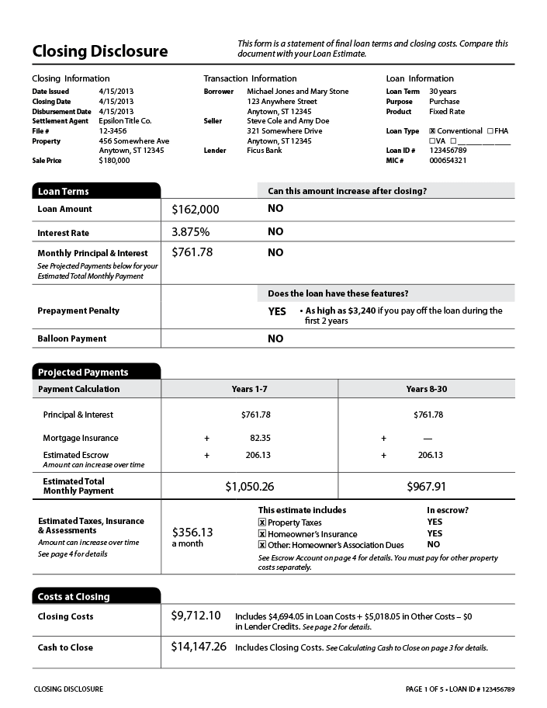

ORLANDO HOME BUYER'S GUIDE 2026

DAVID DOWELL | ORLANDO REALTOR & REAL ESTATE ATTORNEY

CLOSING
38. Final Walk-Through
Central Florida buyer guidance from contract to closing

The final walk-through is usually intended to confirm the property's condition near closing, not to create a new inspection period. Verify that agreed repairs appear complete, included items remain, the property has not suffered new damage and the seller has complied with applicable possession obligations. Your contract controls your remedies if a problem appears.

I just want to re-emphasize that this is only a time to confirm the property is being left in the condition you agreed to. It is not a time to have one final search for problems. Most buyer conduct their final walk through with their realtor the morning of, of evening before, the closing.

ORLANDO HOME BUYER'S GUIDE 2026
DAVID DOWELL | ORLANDO REALTOR & REAL ESTATE ATTORNEY

CLOSING
39. Closing Day
Central Florida buyer guidance from contract to closing

Before closing, confirm wiring instructions using a trusted telephone number obtained independently from the closing agent. Most title companies now will only accept final funds through bank wire transfer. Wire fraud is a serious risk - and becoming more common every year. At closing you will sign the documents required for the purchase and, if financed, the loan. Funds are delivered, closing conditions are satisfied, and title documents are recorded as part of the closing process.

You will walk out of the closing with keys to your new home and a promise from the title company to email all executed docs by the end of the day. Although the title company keeps the original docs, you may want to take with you a copy of the new Warranty Deed so that you have proof of purchase if you hook up utilities, get insurance, and so on.

WIRE FRAUD WARNING
Treat any emailed change to wiring instructions as suspicious. Verify instructions directly with the title company or closing attorney using a known number - not a number supplied in a suspicious email.

ORLANDO HOME BUYER'S GUIDE 2026
DAVID DOWELL | ORLANDO REALTOR & REAL ESTATE ATTORNEY

OWNERSHIP
40. After Closing
Central Florida buyer guidance from contract to closing

Post closing can be a hectic time with the moving and contacting everyone you know, but pay special attention to the following:

Secure keys, remotes, codes and mailbox information.
Change locks or access codes as appropriate.
Confirm utilities and insurance remain/are in force.
Make sure they HOA has your name and contact info.
Keep closing and title documents in a safe place.
Investigate homestead exemption if the property is your qualifying Florida primary residence.
Create a maintenance calendar for HVAC, roof, pool, plumbing and other major systems.

ORLANDO HOME BUYER'S GUIDE 2026
DAVID DOWELL | ORLANDO REALTOR & REAL ESTATE ATTORNEY

STRATEGY
41. Buying Before Selling
Central Florida buyer guidance from contract to closing

If you own another home, decide how the two transactions interact. Options can include selling first, making a purchase contingent on sale, bridge or other financing, using available liquidity, or negotiating occupancy. Each approach changes leverage, cost and risk. Build the sequence before making an offer.

Make sure you speak with your realtor and/or attorney before buying or selling. There are strategy decisions that can be made as well as legal and tax consequences of doing one before the other.

ORLANDO HOME BUYER'S GUIDE 2026

DAVID DOWELL | ORLANDO REALTOR & REAL ESTATE ATTORNEY

RELOCATION
42. Relocating to Orlando
Central Florida buyer guidance from contract to closing

Relocation buyers should compare daily life, not just houses. Test-drive likely commutes, visit communities at different times, compare toll-road access, evaluate airport routes, understand weather and insurance considerations, and decide how close you truly want to be to attractions, employment centers and family.

RELOCATION METHOD
A useful approach is to choose three finalist areas, then compare homes within those areas. This prevents a beautiful house from distracting you from a location that does not fit your life.



ORLANDO HOME BUYER'S GUIDE 2026

DAVID DOWELL | ORLANDO REALTOR & REAL ESTATE ATTORNEY

RELOCATION
43. Out-of-State Buyers
Central Florida buyer guidance from contract to closing

Out-of-state buyers can complete much of the process remotely using video tours, electronic signatures and coordinated inspections. Still, do not let convenience reduce diligence. Request detailed video of streets, lots, neighboring properties and visible condition, and use independent inspectors rather than relying on listing photos.

Your Realtor should assist you in coordinating everything you need. With your agent’s help, along with electronic communications and property videos, you should be able to take care of evreything from home search to closing right from your out-of-state home.

ORLANDO HOME BUYER'S GUIDE 2026

DAVID DOWELL | ORLANDO REALTOR & REAL ESTATE ATTORNEY

SPECIAL PURCHASES
44. Vacation & Second Homes
Central Florida buyer guidance from contract to closing

A vacation or second home near Orlando should be evaluated for personal enjoyment, carrying cost, management and use restrictions. If rental income is part of the plan, verify zoning, HOA rules, licensing, management costs and financing treatment before assuming short-term rentals are permitted or profitable.

Your Realtor should be able to obtain financials from any seller who has a rental property listed for sale. Your agent will also be able to put together a pro forma financial if the property has no prior rental history.

Investment homes near the Walt Disney World Resort are extensive and in very high demand. Whether you are looking for a single family home, a condo, or a townhouse, there are many options available. The one that’s right for you may depend on how you plan to use it - 12 month rental, for you and your family, or some combination of both.

Your realtor can discuss the pros and cons with you.

ORLANDO HOME BUYER'S GUIDE 2026
DAVID DOWELL | ORLANDO REALTOR & REAL ESTATE ATTORNEY

SPECIAL PURCHASES
45. Investment Property Basics
Central Florida buyer guidance from contract to closing

An investment purchase should be analyzed as a business decision. Estimate realistic rent, vacancy, management, repairs, capital expenditures, insurance, taxes, HOA costs and financing. Separate appreciation hopes from the property's current operating economics.

Metric | Question
Gross rent | What is supportable by comparable rentals?
Vacancy | What conservative allowance is reasonable?
Operating costs | Insurance, taxes, HOA, management, maintenance?
Capital reserves | Roof, HVAC, appliances and major replacements?
Exit strategy | Who is the likely future buyer?

ORLANDO HOME BUYER'S GUIDE 2026
DAVID DOWELL | ORLANDO REALTOR & REAL ESTATE ATTORNEY

SPECIAL PURCHASES
46. Foreign Buyers
Central Florida buyer guidance from contract to closing

Foreign nationals can generally purchase Florida real estate, but immigration status, financing, tax, entity structure, estate planning, source-of-funds rules and future disposition can create additional issues. Obtain appropriate U.S. legal and tax advice before choosing an ownership structure or assuming the tax consequences will mirror those in your home country.

David Dowell is both a Realtor and Attorney who can discuss with you any issues that a foreign buyer may have.


ORLANDO HOME BUYER'S GUIDE 2026
DAVID DOWELL | ORLANDO REALTOR & REAL ESTATE ATTORNEY

AVOID THESE
47. Common Buyer Mistakes
Central Florida buyer guidance from contract to closing

Shopping before establishing a realistic all-in budget.
Choosing a neighborhood based only on listing photos.
Ignoring insurance until late in the transaction.
Treating the inspection as a pass/fail test.
Focusing only on purchase price instead of terms and total cost.
Making large financial changes before loan closing.
Assuming HOA rules will allow a planned use.
Missing contractual deadlines.
Waiving protections without understanding the risk.
Skipping title, survey or specialist review when an issue deserves investigation.

ORLANDO HOME BUYER'S GUIDE 2026
DAVID DOWELL | ORLANDO REALTOR & REAL ESTATE ATTORNEY

ACTION PLAN
48. A 60-Day Buyer Plan
Central Florida buyer guidance from contract to closing

Timing | Action
Days 1-7 | Define goals, budget, financing and target areas
Days 8-14 | Pre-approval, insurance conversations, search setup
Days 15-30 | Tour areas and homes; refine criteria
Days 31-45 | Analyze finalists; prepare offer strategy
Under contract | Deposit, inspections, insurance, financing, appraisal, title/survey
Final week | Closing Disclosure, final walk-through, verified funds and closing logistics

ORLANDO HOME BUYER'S GUIDE 2026

DAVID DOWELL | ORLANDO REALTOR & REAL ESTATE ATTORNEY

CHECKLIST
49. Buyer Checklist
Central Florida buyer guidance from contract to closing

Government-issued identification
Pre-approval or proof of funds
Down-payment and closing-cost plan
Target area list
Must-have / preference list
Insurance contact
Inspector options
Lender contact
Attorney/title/closing contact as applicable
Calendar of all contract deadlines
Final walk-through plan
Verified wiring instructions

ORLANDO HOME BUYER'S GUIDE 2026
DAVID DOWELL | ORLANDO REALTOR & REAL ESTATE ATTORNEY

TEAM
50. Questions to Ask Your Realtor
Central Florida buyer guidance from contract to closing

How does this neighborhood compare with nearby alternatives?
What recent sales are most relevant to this property?
How long has the home been on the market and has pricing changed?
What terms besides price may matter to this seller?
What concerns do you see about condition, resale or location?
What inspections or specialists should I consider?
How will you track my contract deadlines?
What happens if the inspection, financing or appraisal creates a problem?
How will we evaluate new construction versus resale?
How will you help me avoid overpaying?

ORLANDO HOME BUYER'S GUIDE 2026
DAVID DOWELL | ORLANDO REALTOR & REAL ESTATE ATTORNEY

TEAM
51. Questions to Ask a Lender
Central Florida buyer guidance from contract to closing

What is my estimated all-in monthly payment?
What assumptions are you using for taxes and insurance?
What are the rate, APR, points and lender fees?
Is there a prepayment penalty?
What could cause my approval to change?
How does an HOA or condo affect qualification?
What seller concessions are permitted?
When can I lock the rate and for how long?
How much cash should I expect to bring to closing?
What should I avoid doing financially before closing?

ORLANDO HOME BUYER'S GUIDE 2026
DAVID DOWELL | ORLANDO REALTOR & REAL ESTATE ATTORNEY

LEGAL
52. Attorney's Contract Checklist
Florida buyer guidance from contract to closing

Correct parties and property
Purchase price and deposit timing
Financing terms and deadlines
Inspection rights and deadline
Appraisal provisions, if any
Title and survey provisions
HOA/condo disclosures and document rights
Personal property and fixtures
Closing date and possession
Seller concessions and credits
Default/remedy provisions
Addenda, riders and special clauses

This checklist is educational only. The actual contract and facts of a transaction determine the parties' rights.

ORLANDO HOME BUYER'S GUIDE 2026
DAVID DOWELL | ORLANDO REALTOR & REAL ESTATE ATTORNEY

REFERENCE
53. Buyer Glossary
Central Florida buyer guidance from contract to closing

Appraisal: A valuation prepared for a lender or other client by a licensed or certified appraiser.
Closing Disclosure: A federal disclosure used in many consumer mortgage transactions showing final loan and closing figures.
Comparable sale: A recent sale used as evidence when analyzing a property's value.
Contingency: A contractual condition or right tied to specified events and deadlines.
Earnest money / deposit: Funds placed with an escrow holder under the purchase contract.
Escrow: An arrangement in which a neutral holder maintains money or documents subject to agreed instructions.
HOA: Homeowners association that may impose dues, restrictions and community rules.
Inspection period: The contractually defined period for property investigation and related rights.
Loan Estimate: A federal mortgage disclosure showing estimated loan terms and closing costs.
Pre-approval: A lender's preliminary credit decision based on information reviewed; not a guarantee of final funding.
Survey: A professional depiction of boundaries and certain physical features or encumbrances.
Title insurance: Insurance against covered title defects, subject to the policy's terms and exceptions.
Walk-through: A pre-closing visit to confirm condition and contractual matters near closing.

ORLANDO HOME BUYER'S GUIDE 2026
DAVID DOWELL | ORLANDO REALTOR & REAL ESTATE ATTORNEY

LET'S BUILD YOUR BUYING PLAN
54. Your Next Step
Central Florida buyer guidance from contract to closing

The strongest purchase usually begins before the first offer. We can define your price range, identify the communities that fit your goals, create a search strategy, and prepare a contract and negotiation approach so that when the right home appears, you are ready to act intelligently rather than react under pressure.

COMPLIMENTARY ORLANDO BUYER STRATEGY SESSION
A buyer strategy session can cover your goals, timing, target neighborhoods, financing status, likely monthly costs, new construction versus resale, and the practical steps from search through closing.

DAVID DOWELL
Orlando Realtor & Real Estate Attorney
Windermere • Winter Garden • Horizon West • Clermont • Dr. Phillips
FREE Phone/Zoom Consultation - calendly.com/daviddowell
Phone/Text: (407) 801-1614
Email: ddowell500@gmail.com
Youtube: @daviddowellrealestate
Instagram: thedaviddowell
Website: yourorlandorealty.com

ORLANDO HOME BUYER'S GUIDE 2026
DAVID DOWELL | ORLANDO REALTOR & REAL ESTATE ATTORNEY

REFERENCE
Important Florida & Federal Resources
Central Florida buyer guidance from contract to closing

Because laws, forms, lending rules, taxes, insurance requirements and association requirements can change, verify current information for your specific transaction. Useful official sources include the Florida Department of Revenue, county property appraisers, FEMA flood resources, the Consumer Financial Protection Bureau, the IRS, and the applicable local government or association.

This guide is general educational material. It is not a substitute for individualized legal, tax, lending, insurance, inspection or financial advice, and no attorney-client relationship is created by receiving it.

ORLANDO HOME BUYER'S GUIDE 2026

